CEG 4166 – Real-Time Systems Design
Laboratory 5: Autonomous Maze Traversal and Obstacle Avoidance of the Stingray Robot with Live Mapping and Object Detection

Winter 2025
University of Ottawa
Faculty of Engineering, School of Electrical Engineering and Computer Science
Section 2
TAs: Devansh Kumar, Kamran Gholizadeh Hamlabadi

Group 9
Stingray 22
Team Members:
Keith Tran – 300240028 – ktran033@uottawa.ca
Kevin Dang – 300241133 – kdang038@uottawa.ca
Saurav Guduru – 300234999 – sgudu104@uottawa.ca

Submission Date: 2025-04-04
Table of Contents
Introduction 3
Objectives 3
Background Material 3
Functionality Scope 3
Theory 3
Real World Modelling 3
Control Principles 3
Programming Concepts 3
Experimental Setup 4
Hardware Architecture 4
Software Architecture 4
Testing Methodology 5
Results and Observation 5
Discussion 5
Challenges 5
Solutions 5
Results 5
Future Recommendations 6

Introduction

Objectives
The objectives of the laboratory are as follows:
- Implement autonomous traversal of the Stingray Robot through a maze, while avoiding obstacles in real time.
- Display a graphical user interface (GUI) that displays the movements of the Stingray Robot while traversing the maze.
- Display a live video stream of the objects detected by the Stingray Robot while traversing the maze.

Background Material
This lab builds upon all previous labs, by combining the results of each to perform the final test of autonomously traversing a maze, with a GUI to visually track its movements.

Functionality Scope
The functionality to be implemented for this lab are as follows:
Autonomous maze traversal: The robot traverses a maze autonomously while avoiding obstacles
GUI: a GUI displays the movements of the robot on a screen
Live video stream: A live video stream from the PiCamera records objects detected by the robot

Theory

Real World Modelling
This lab uses real time modeling using both the camera and sonar that is attached to the stingray to detect objects in real time while traversing the maze. The stingray will move forward until it detects any obstacles then it will sweep left and right to determine the best path to avoid the obstacle. Additionally, the GUI that is displayed on the attached screen allows for better real time modeling by showing the stingray’s current position and path as it traverses the maze in real time.

Control Principles
This lab applies control principles seen in the previous labs such as PID (Proportional-Integral-Derivative) control to allow the stingray to move in our desired direction. For obstacle avoidance, the stingray uses the data from the sonar to detect obstacles, sweep both directions, and determine the best path before continuing to navigate the maze. Multi-threading enables us to execute tasks in parallel such as live GUI updates, object classification with the camera, obstacle avoidance, and the movement of the stingray.

Programming Concepts
The following are the important programming concepts used in this lab.
Multithreading and concurrency: the different functions of the robot were executed on separate threads that ran concurrently.
Object-oriented programming: subsystems of the robot (e.g. wheel movement, sensor, camera) were virtualized as objects in the code, each with their own attributes and functions and instantiated in one shared main running program.
Use of packages: python packages were imported to make use of external tools and libraries in our code. Packages were included to implement multithreading, interact with the PiCamera, and use the OpenCV library for image processing and computer vision tasks.
Machine learning model: using the camera feed, a machine learning model detects and identifies faces.
Graphical user interface (GUI): a GUI is implemented using the Tkinter library
Writing into files on the computer: a function is called by the GUI to write a list of all obstacles detected into a file and save it somewhere on the system drive.

Experimental Setup

Hardware Architecture
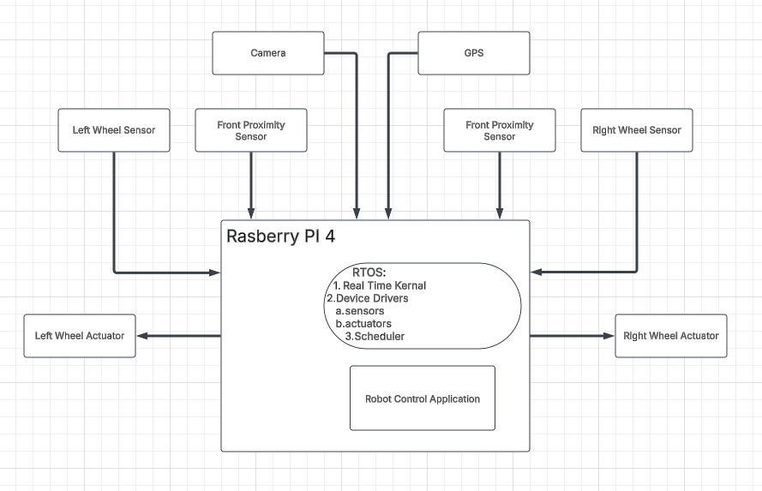

Software Architecture
The software architecture is comprised of the following program modules:
- GUI_path.py: creates the GUI that simulates the maze and tracks the movement of the pi while also printing an event log. Stores each obstacle detected into a list with time detected, position in the maze, heading of the robot, and distance from the object. The list can then be written into a new text file.
- Lab5.py: the main running program that integrates all software components
- KeyboardGPIO.py: defines the keyboard controls, with mapping of keys to specific functions of the robot
- PID.py: a virtualization of the PID controller
- PlotDataRobot_Lab3.py: plots the data concerning the robot’s movement on a graph
- WheelEncoderGPIO.py: defines the encoding for the wheel servos
- CameraGPIO.py: defines the camera component of the robot
- UltrasonicGPIO.py: defines the graphical user interface displayed on the robot
- Object_detection.py: defines the machine learning model responsible for detecting and classifying objects via the PiCamera

Testing Methodology
Our methodology for testing was to first test individual components of the program at a time, then gradually test components together, before testing all the components running under one program. This was done by commenting out atomic modules of the code that were not immediately related to the specific function currently being tested.
For the GUI, a standalone build was created to test the GUI separately from the robot. The movement of the robot through the maze as displayed by the GUI was simulated by mapping keyboard inputs to specific movements of the robot. Functions that would normally only be triggered by signals from the robot (such as obstacle_detection() and save_file() were mapped to temporary buttons on the GUI (which would be removed when integrating it with the rest of the robot’s system).
When testing the robot, the main point of testing were the parameters of the servos and wheels of the robot. The extent at which wheels spun for each given command (ex. Turn left, turn right, move forward, move backward) needed to be fine-tuned for the robot to turn at the desired precise angle, or to move forward exactly one tile’s length in order to sync the movement of the pointer through the GUI maze with the movement of the robot in the actual maze. To achieve this, trial-and-error was exercised until the right values were found.

Results and Observation
The source code for this lab can be found zipped in the file titled the following: “CEG4166_2025W_Section2_Group9_Lab5_Code_20250404-01.zip.”
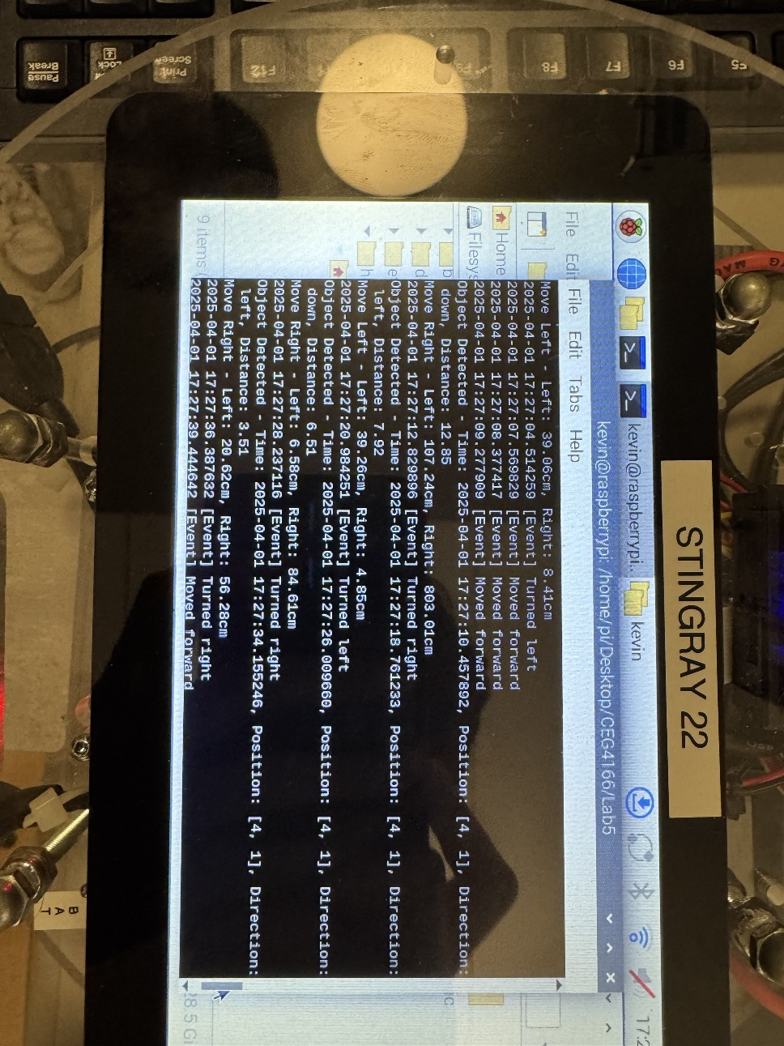
Figure 1: List of events and obstacles detected displayed as output by the robot. The list of obstacles can also be saved into a text file.
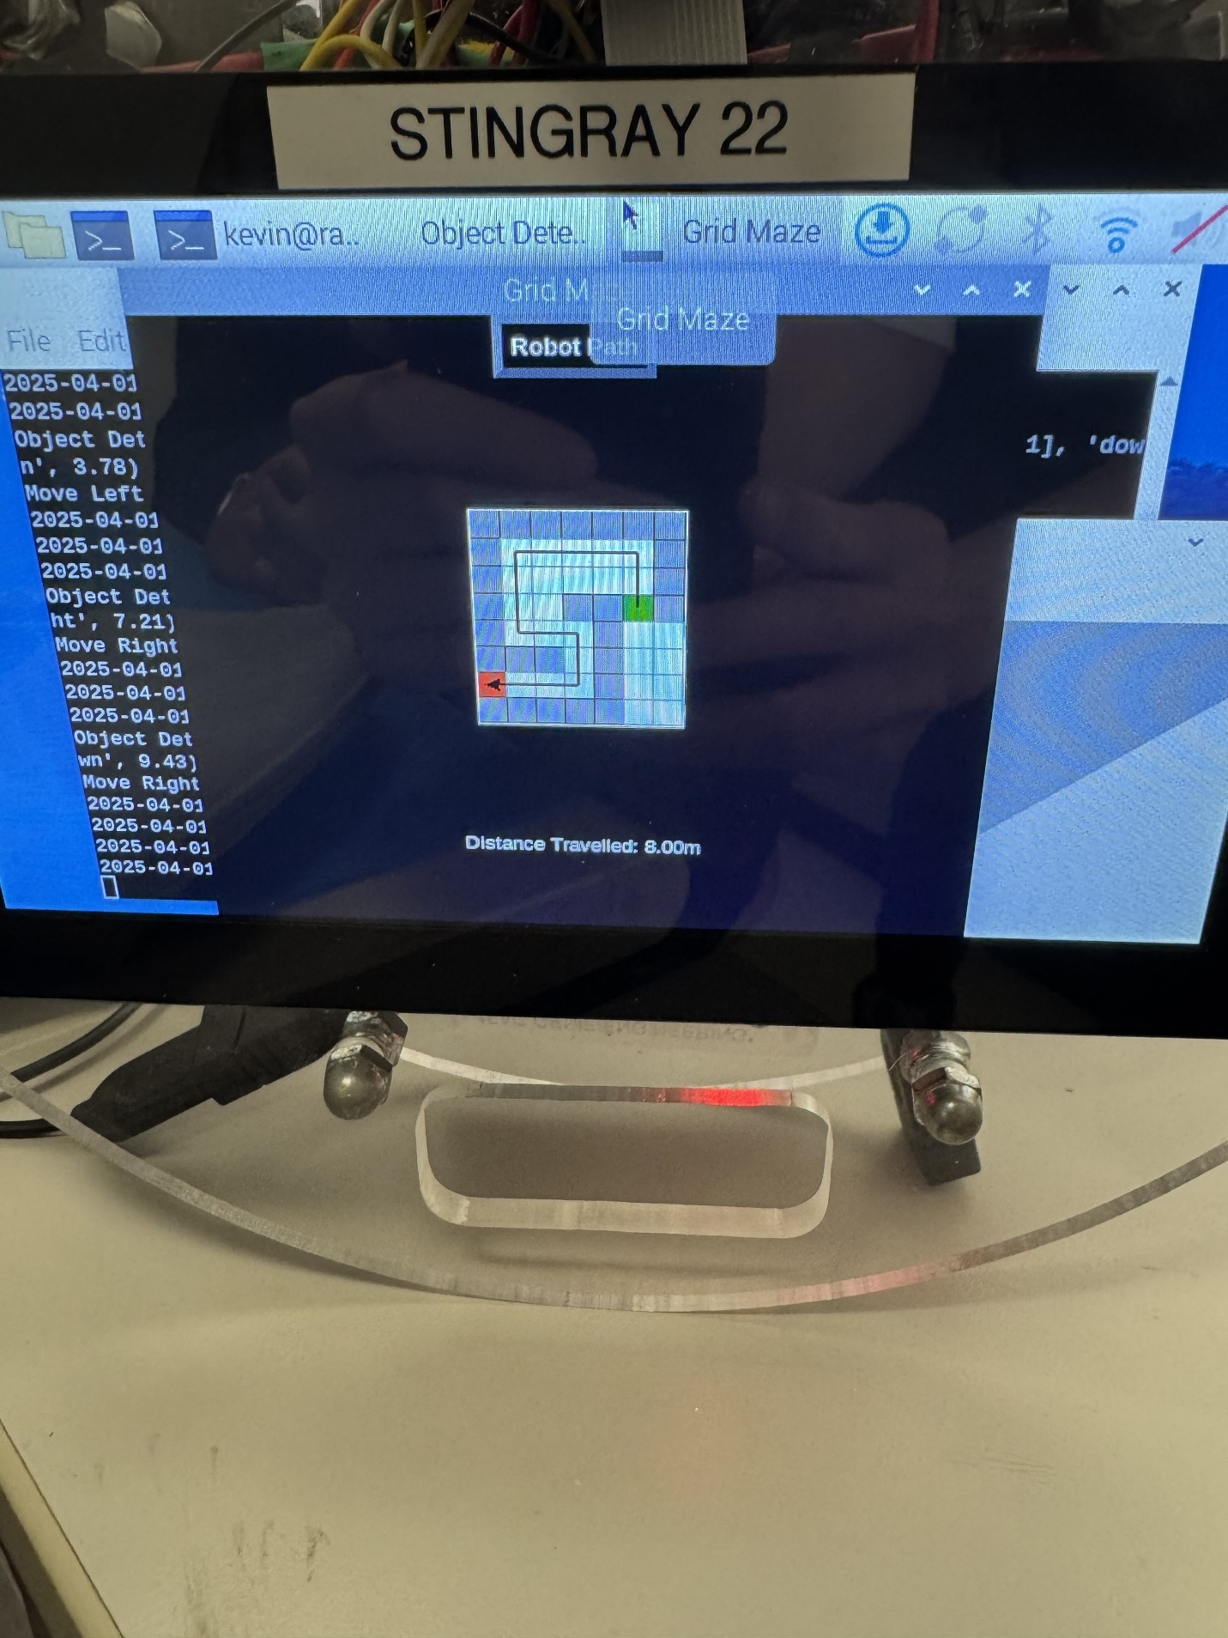
Figure 2: GUI showing the Stingray’s maze traversal.

Discussion

Challenges
Throughout this lab we encountered several challenges some which occurred while writing out algorithm and some occurred while testing. We wrote our algorithm just that the robot moves forward and upon detecting an obstacle, a sweep is done by the ultrasonic sensor, and the robot turns according to open space. We had troubles with the ultrasonic sweeping, often it would have a lot of jitter and sometimes also get stuck in a certain position. We made sure that it swept from left to right, and we used 5 samples to measure distances during this sweep. This led to incorrect calculations of the average distance on the left and right which resulted in false turns. Another challenge was tuning the PID forward and robot turn to precisely move the robot one tile forward or turn exactly 90-degrees.

Solutions
To address the PID forward tuning challenge, we conducted extensive trial-and-error testing. We adjusted the distance measurement for the move_forward() function while checking the robot's ability to move exactly one tile. We did the same for the turning, we adjusted the delay of each motor to ensure that the robot turns right and left in 90-degree turns all the time. For the ultrasonic sensor, instead of performing a continuous sweep we decided to use 3 fixed points one at 90 degrees, 45 degrees and 135 degrees for the sweeping. This prevented jitter and the ultrasonic sensor staying stationary in one position for too long. By doing this it also allowed for more accurate sampling of the distances on the left and right, so that the robot can determine which direction to turn in for obstacle avoidance.

Results
For the most part, the results of the lab were close to what was expected. The Stingray was able to fully traverse the maze, although it did collide with some obstacles. The GUI effectively updated itself and displayed the movements of the Stingray in real-time in a timely manner, as well as printing a log of all the robot’s actions and all the obstacles it detected.

Future Recommendations
In future iterations, we recommend replacing ultrasonic-based obstacle detection with vision-based detection using the PiCamera, like Tesla’s approach. Training a deep learning model on images from multiple angles could allow the robot to detect and classify objects with higher accuracy and make smarter navigation decisions.

